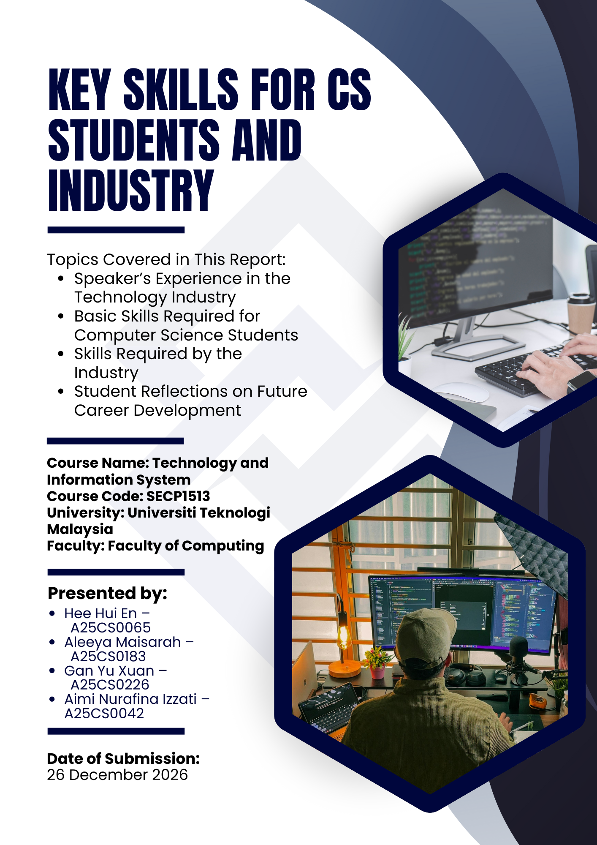

1
Description Of the Speaker Experience
The speaker who names TS. HJ. Abdul Alim Bin Abdul Muttalib is a graduate of Universiti Teknologi Malaysia and previously stayed at Kolej Tun Razak (KTR). After graduating, he did not have the opportunity for work and he got a job in September 2015. The first three years when he was working after graduating, he struggled and started trying to find old notes and trying to understand the fundamentals that had been taught. He realized that he just treated what he had learned in university as a chapter in the textbook and did not relate it to his work life. Especially during the interview, he was aware that he was difficult to explain the knowledge that has been learned specifically when the interviewer asked him about the Software Development Life Cycle (SDLC).

Basic Skills Required for Computer Science Students
Based on the industry talk, the speaker mentioned several key skills needed for computer science graduates to succeed in the industry. Apart from technical skills such as coding and using development tools, students must understand system development and project management basics like requirement analysis, planning, design, testing, deployment and maintenance. Teamwork, communication and coordination skills are also important because the real-world systems are built collaboratively rather than individually. In addition, he says that graduates must learn how to use AI as an assistive tool to guide them to improve their work without fully relying on it to ensure they have strong problem-solving abilities. Overall, having both technical skills and soft skills is important for computer science students to stay relevant and get hired in the industry.

Skills Required by Industry
The speaker claims that in the technology industry nowadays graduates are expected to have strong project management (PM) skills that may allow employers to effectively manage tasks and boost productivity. However, the introduction of agile development skills fulfils the industry's need for flexibility and quick responses on shifting requirements. Furthermore, the industry aims for a high value on architecture and abilities of system design that support the creation of complex and manageable systems since agentic coding became familiar in this era. Therefore, the speaker also underlined how crucial it is to use artificial intelligence wisely in order to boost output while preserving human oversight and decision-making. This shows effective communication, teamwork, flexibility and the ability to produce solutions in a short range of time.

Reflection: How you will successful in the computer science in next four year?
My reflection is that the skills of project management and system development are crucial to be involved in my whole study years. It can control the work wisely and avoid chaos. It is essential to fully understand the fundamentals of knowledge about what I learned and relate it in my life instead of remembering it to pass exams. From the talk, I get the advice that I have to utilize AI intelligently to assist myself to solve problems and optimize projects, rather than rely on AI to complete it. Since computer science is a rapidly developing course, I realized adopting an agile mindset is important. Not only exploring and non-stop learning new knowledge, but also enhancing the related skills such as communication skills and collaboration skills in a team. I also have to engage in some competition and projects to gain extra experience. It will be helpful for my future career and to be successful in computer science in the next four years.

(Hee Hui En)

Through the talk, I truly understand that it is important to practice project management skills in order to apply the professional knowledge learned in university to real-world situations rather than focusing on academic life and the syllabus. Therefore, I realized that it is crucial for me to begin developing problem-solving, teamwork, and communication skills by applying the Software Development Life Cycle (SDLC) through each group assignments and projects to master fundamental concepts and emerging technologies required in computer science and the industry. As a university student in this technological era, I should use artificial intelligence tools responsibly to assist my learning journey but not rely on it entirely. By continuously learning and applying knowledge practically, I believe that I will be well-prepared to succeed in computer science studies and future career.
(Gan Yu Xuan)
After attending this industry talk, I realized that success in the computer science field needs early preparation and consistent effort. The speaker made me understand that technical skills, system development and project management are important skills used in a real-working environment. Over the next four years, I plan to strengthen my programming skills by practicing regularly and using my knowledge through projects and internships. I will also focus on improving my communication skills and confidence when working in teams since most real-world projects are done together. I will participate in workshops, competitions and industry talks to help me gain exposure to real-world expectations. By combining technical knowledge with strong discipline and a positive attitude, I believe that I can be successful in the computer science field.
(Aleeya Maisarah)
The talk made me reflect on how important it is to truly understand what we learn in computer science instead of just completing assignments or passing exams. The speaker’s journey showed that without strong fundamentals, it can be challenging to explain ideas or apply knowledge confidently in real situations such as interviews or work tasks. From this, I learned that skills like planning, system thinking, and managing development processes are just as important as coding itself. In the next four years, I want to focus on learning through experience by taking part in projects, learning from mistakes, and improving how I communicate ideas with others in a team. I also realized that while AI can be helpful, relying on it too much can limit my own thinking, so I need to use it carefully to support learning rather than replace it. With consistent effort and willingness to learn beyond the classroom, I believe I can grow steadily and build a strong future in computer science.
(Aimi Nurafina Izzati)
Reference
- John Morley. (2023). Academic Phrasebank. https://www.phrasebank.manchester.ac.uk/
- How to write in an academic style. (n.d.-b). The University of Sheffield. https://sheffield.ac.uk/study-skills/writing/academic/style
- Khabir, B. (n.d.). Modern home office workspace with developer coding [Photograph].Pexels. https://www.pexels.com/photo/modern-home-office-workspace-with-developer-coding-33637962/
- Ravikiran, A. S. (2025, September 11). What is switch case in Java and how to use switchstatementinJava.Simplilearn. https://www.simplilearn.com/tutorials/java-tutorial/switch-case-in-java

